Profiling Data
- Missing values distribution (Count of null values in all columns used UNION ALL syntax to show all columns with one query)
SELECT
'price' AS metric,
COUNTIF(price IS NULL) AS missing
FROM `projectspractice12.sp500dataAnalysis.sp500data_clean`
UNION ALL
SELECT
'priceToEarnings',
COUNTIF(priceToEarnings IS NULL)
FROM `projectspractice12.sp500dataAnalysis.sp500data_clean`
UNION ALL
SELECT
'dividendYield',
COUNTIF(dividendYield IS NULL)
FROM `projectspractice12.sp500dataAnalysis.sp500data_clean`
UNION ALL
SELECT
'EarningPerShare',
COUNTIF(EarningPerShare IS NULL)
FROM `projectspractice12.sp500dataAnalysis.sp500data_clean`
UNION ALL
SELECT
'ebitda',
COUNTIF(ebitda IS NULL)
FROM `projectspractice12.sp500dataAnalysis.sp500data_clean`
UNION ALL
SELECT
'PriceToSales',
COUNTIF(PriceToSales IS NULL)
FROM `projectspractice12.sp500dataAnalysis.sp500data_clean`
UNION ALL
SELECT
'priceToBook',
COUNTIF(priceToBook IS NULL)
FROM `projectspractice12.sp500dataAnalysis.sp500data_clean`

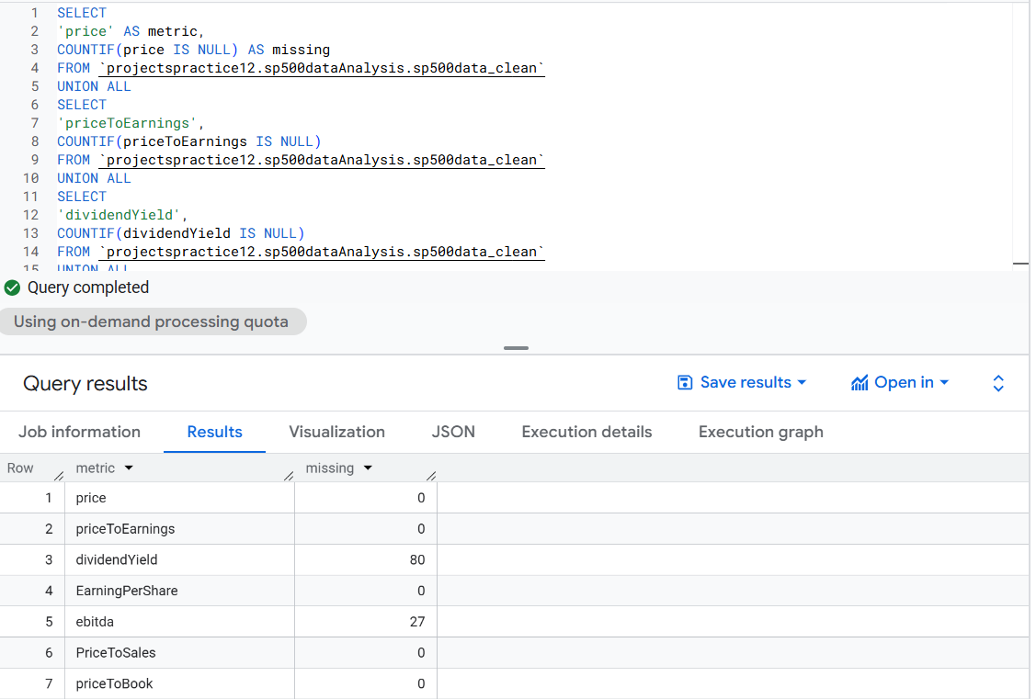

- Outlier detection using IQR (Finding High and Low outliers in P/E and P/S)

WITH bounds AS (
SELECT
metric,
Q1,
Q3,
(Q3 - Q1) AS iqr,
Q1 - 1.5 * (Q3 - Q1) AS lower_bound,
Q3 + 1.5 * (Q3 - Q1) AS upper_bound
FROM (
SELECT
'priceToEarnings' AS metric,
APPROX_QUANTILES(priceToEarnings, 4)[OFFSET(1)] AS Q1,
APPROX_QUANTILES(priceToEarnings, 4)[OFFSET(3)] AS Q3
FROM `projectspractice12.sp500dataAnalysis.sp500data_clean`
UNION ALL
SELECT
'PriceToSales',
APPROX_QUANTILES(PriceToSales, 4)[OFFSET(1)],
APPROX_QUANTILES(PriceToSales, 4)[OFFSET(3)]
FROM `projectspractice12.sp500dataAnalysis.sp500data_clean`
)
)
SELECT
metric,
lower_bound,
upper_bound
FROM bounds;

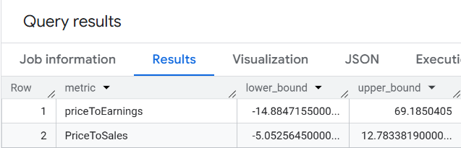

- Sector-level nulls

SELECT
sector,
COUNT(*) AS n,
COUNTIF(priceToEarnings IS NULL) AS null_pe,
COUNTIF(dividendYield IS NULL) AS null_div,
COUNTIF(ebitda IS NULL) AS null_ebitda
FROM `projectspractice12.sp500dataAnalysis.sp500data_clean`
GROUP BY sector
ORDER BY n DESC;

